CSRS Spill to the Gas Cap
- PROJECT INFORMATION
P2 Identifier | 466539
Project Manager (PM) | Jeff Ament (NWP, 503-808-4713)
Technical Lead (TL)
Biologist/Coordination

- PURPOSE
The purpose of this project is to develop spill patterns to maximize spill to the TDG limit, as ordered by Judge Simon.

- BACKGROUND

Dams on the CSRS have been spilling for juvenile fish for years, at various spill percentages/amounts at each dam. A recent court order requires that new spill patterns be developed to increase spill at the dams to the maximum amount possible while not exceeding the TDG limits, and providing good egress conditions for juvenile fish, and not impacting operations/dam safety and minimizing impacts to navigation.

- STATUS & ISSUES
- Spill modeling has begun
- Beginning documentation of new patterns and issues/concerns
- John Day model is not functional, nor at the proper scale to see the hydraulic conditions necessary to ensure the proper spill patterns are developed.

- SCHEDULE & COST

YEAR | COST | MAJOR ACTIVITIES
FY17  Actual Obligation | $2,897,412 | Develop spill patterns at 7 of the 8 dams. Begin design and construction of a new John Day model to allow for this modeling effort
FY18  Need | $6,148,000* | Complete construction of John Day model, calibrate/commission the model, utilize it to develop new spill patterns
*Budget includes biological studies currently under development
- PHOTOS & DRAWINGS
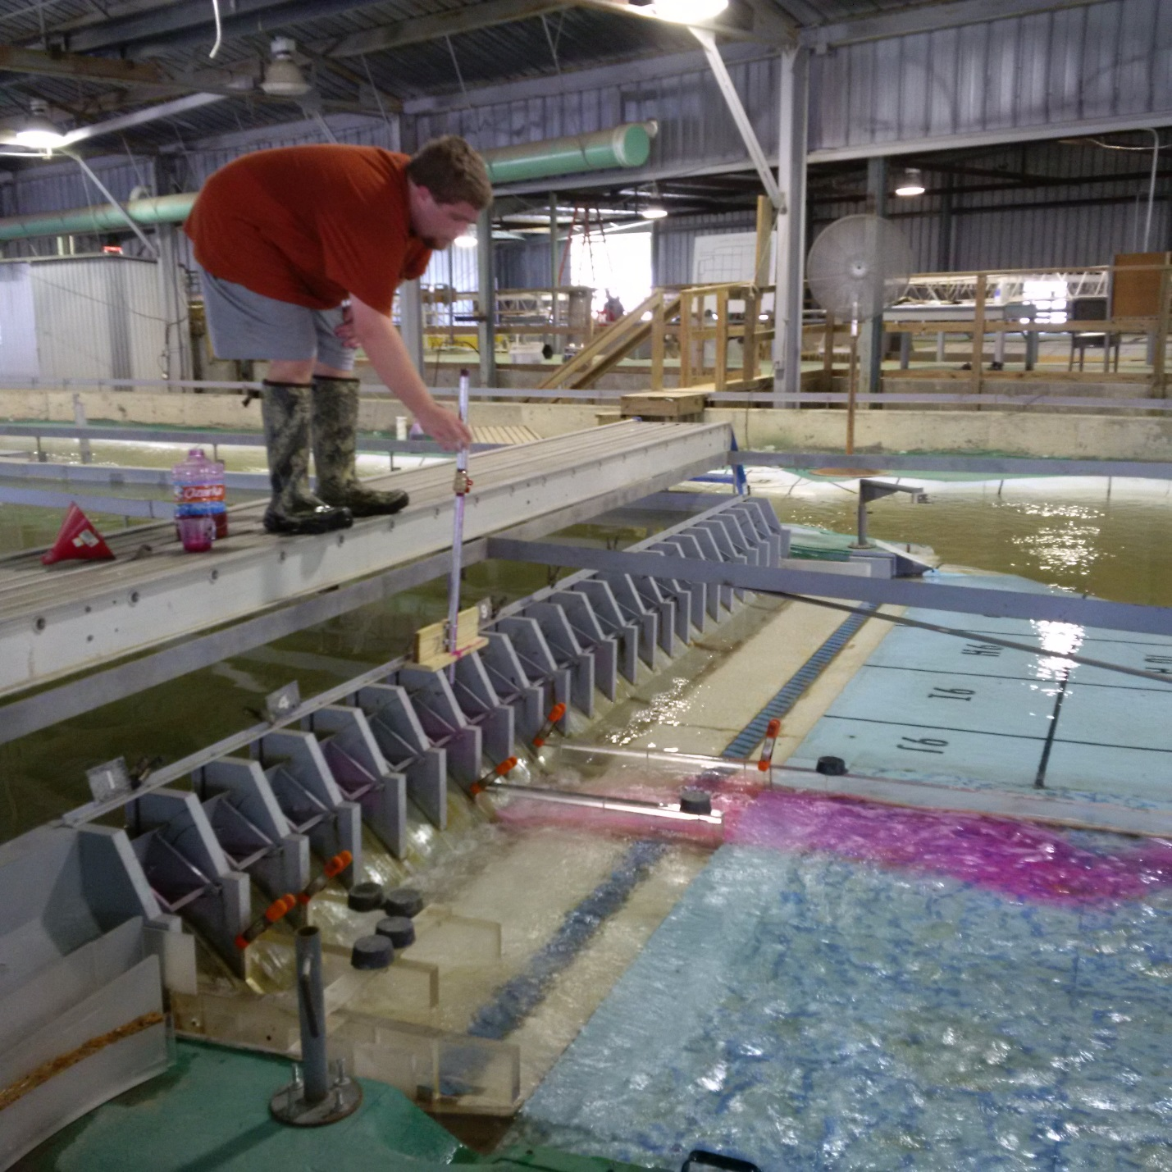
Modeling effort at The Dalles Model

